A000-Indo-Borneo-Dayak-Shaman Mask-Shaped Bone-1890’s

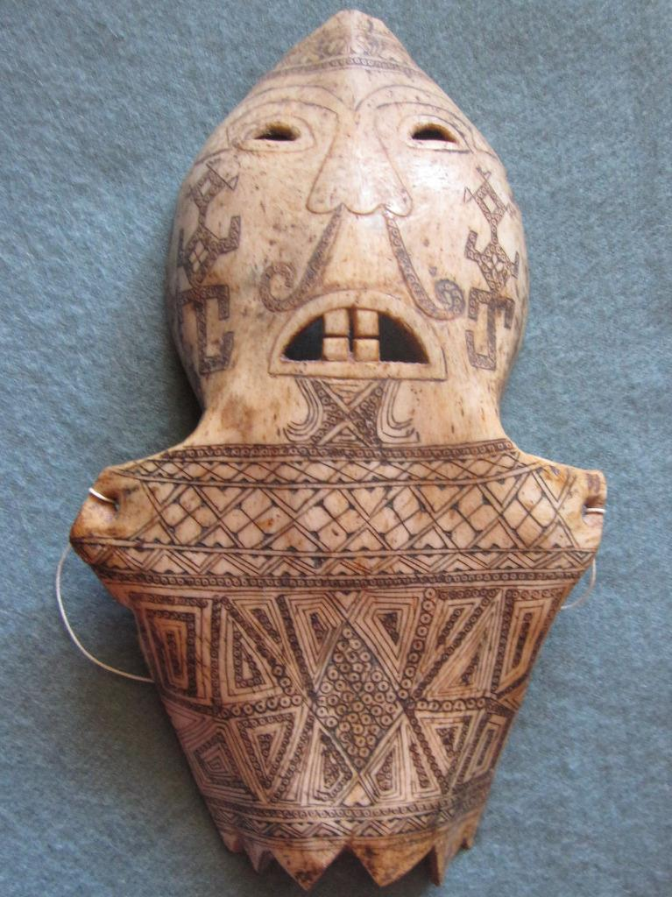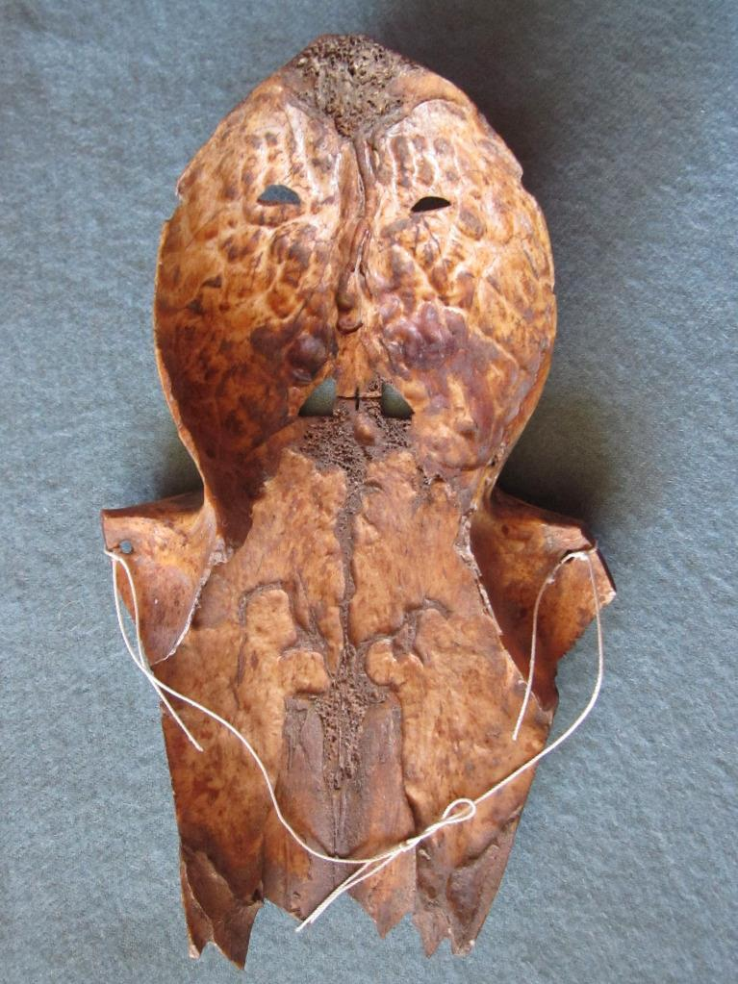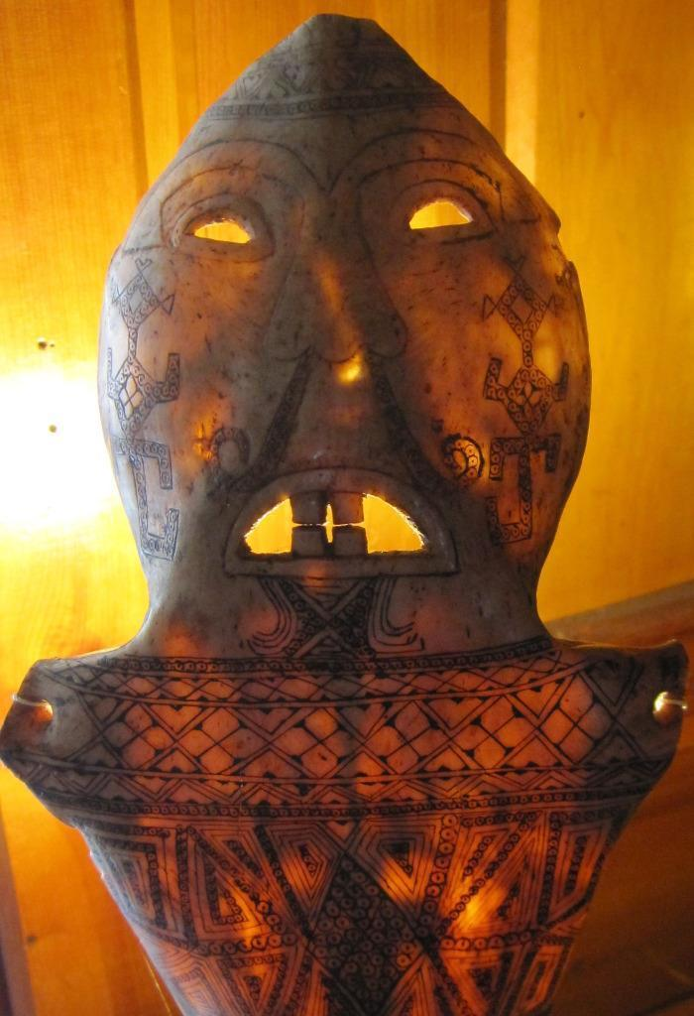

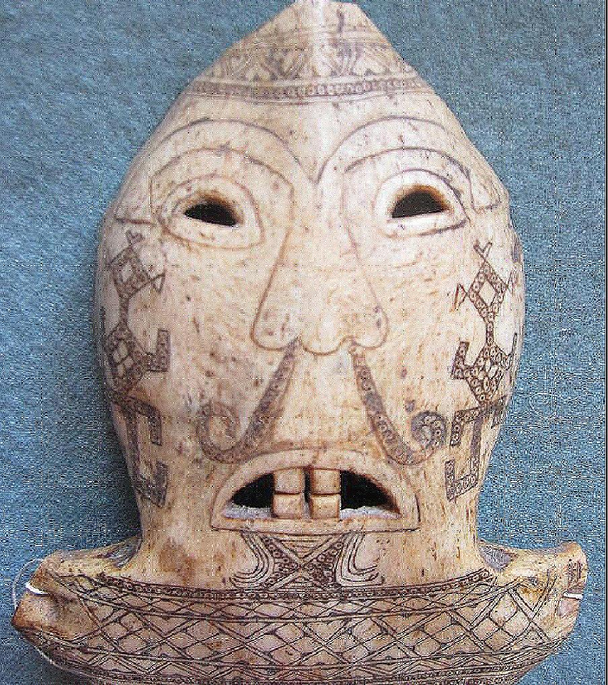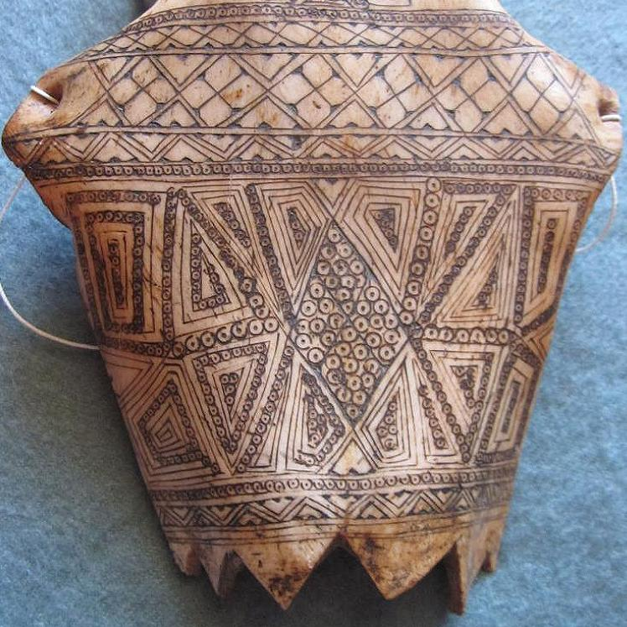

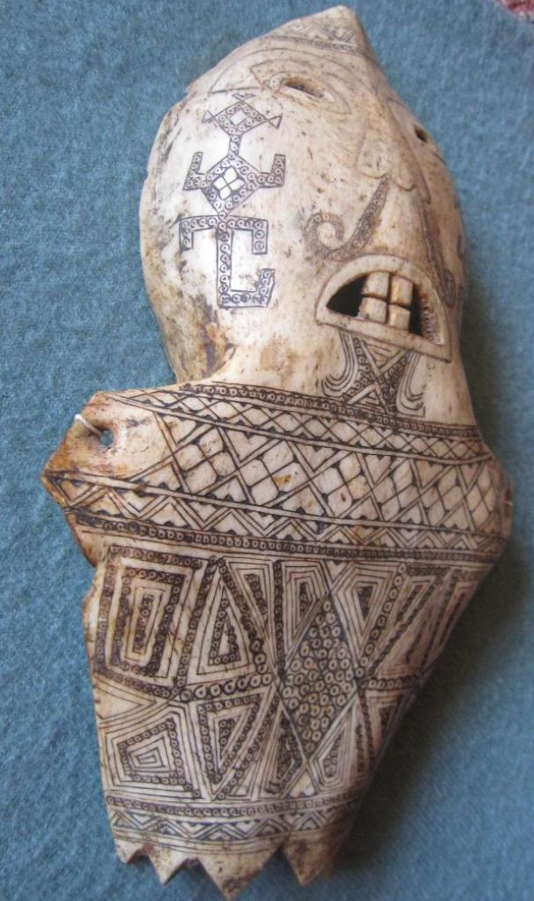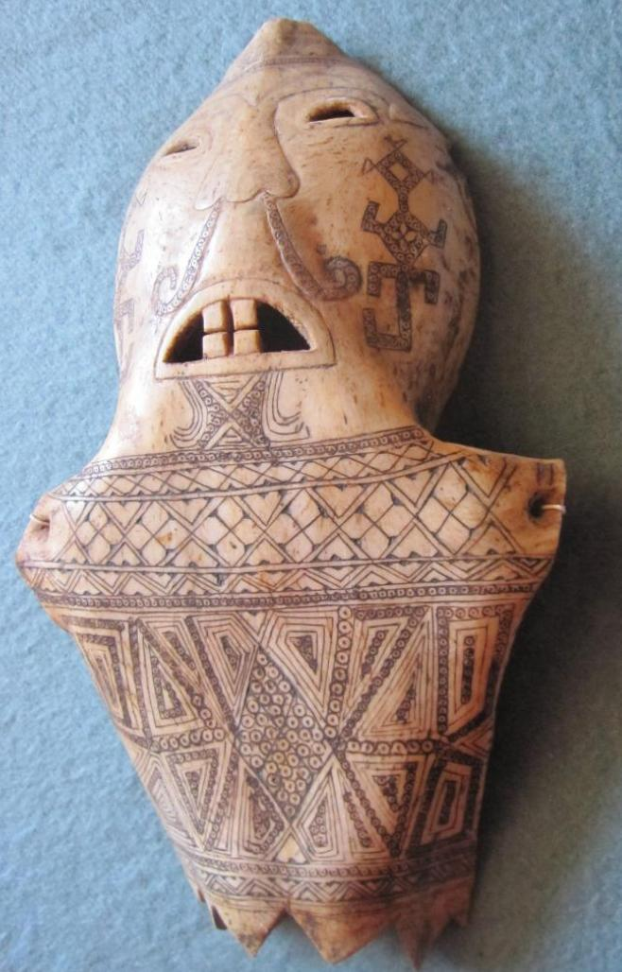

Figs. 1-7. Indo-Borneo-Dayak-Headhunters Skull Mask-Shaped Bone-1890’s

Case No.: Oceania

**Accession No.**

**Formal Label:** Indo-Borneo-Dayak-Shaman Mask-Shaped Bone-1890’s

**Display Description:**

This mask was intricately carved and affixed to the head of a shaman who led the Head Hunting party. After they had returned and after the ceremony of victory, it was placed in the soil (note the zigzags on the bottom of the mask) near the skulls of the deceased to acquire the numinous power of the essence of the spirit of the deceased. These masks therefore carry this numinous power today.

**LC Classification: DS646.32**

**Date or Time Horizon: 1890’s**

**Map:**

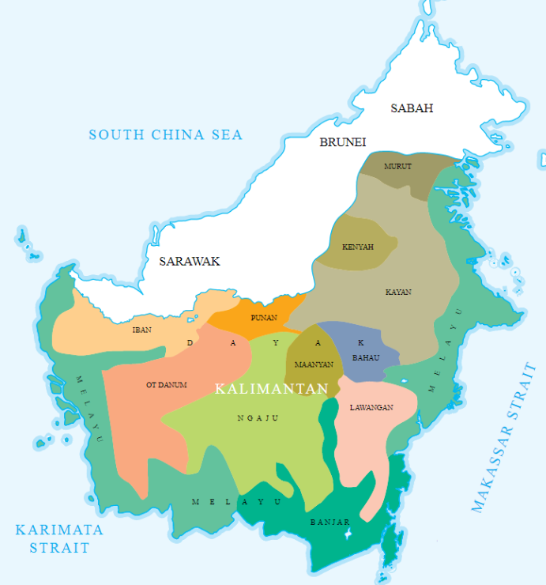

The map of ethnic groups in Borneo (Kalimantan). The map was redrawn and made based on a large map of "Peta Suku Bangsa di Indonesia" displayed in Ethnography Room in National Museum of Indonesia, Jakarta. The image was simply a cropped version highlighting the ethnic groups in Kalimantan from the original.

**GPS coordinates:**

**Cultural Affiliation: Dayak, Kenyah**

**Media: bone, pigment**

**Dimensions:**

**Weight:**

**Condition: original**

**Provenance:** French ethnological collection

**References:**

# Harrisson, T., 1959. Innermost Borneo: Ten Years' Exploration and Research. *The Geographical Journal*, *125*(3/4), pp.299-311.

# Harrisson, T., 1964. Inside Borneo: The Dickson Asia Lecture. *The Geographical Journal*, *130*(3), pp.329-336.

# KNAPEN, H., 2003. Innermost Borneo; Studies in Dayak cultures.

# Sather, C., 2003. Innermost Borneo: Studies in Dayak Cultures. *Asian Ethnology*, *62*(2), p.349.

# Sellato, B., 2002. How Tribes Come into Being: The Ethnogenesis of the Aoheng. *Innermost Borneo: Studies in Dayak Culture*, pp.163-194.

# Appendix:

Below are different representations of Headhunting warriors and Headhunting festivals after the return.



**Dayak Headhunters in Borneo, 1823**

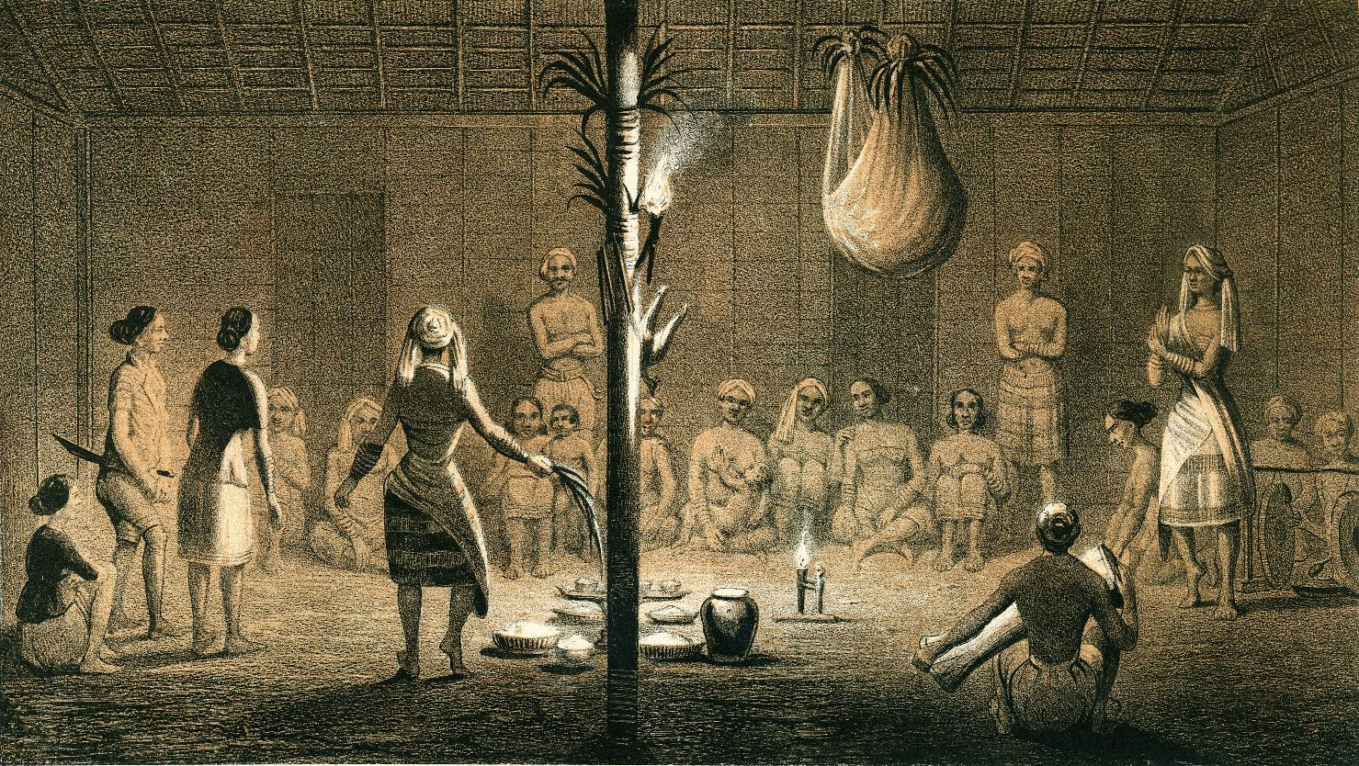

Dayak festival After C.A.L.M. Schwaner, 1846. Borneo. Ein Bilianfest der Dayak von Sungi Pattaym. Amsterdam, van Kampen.

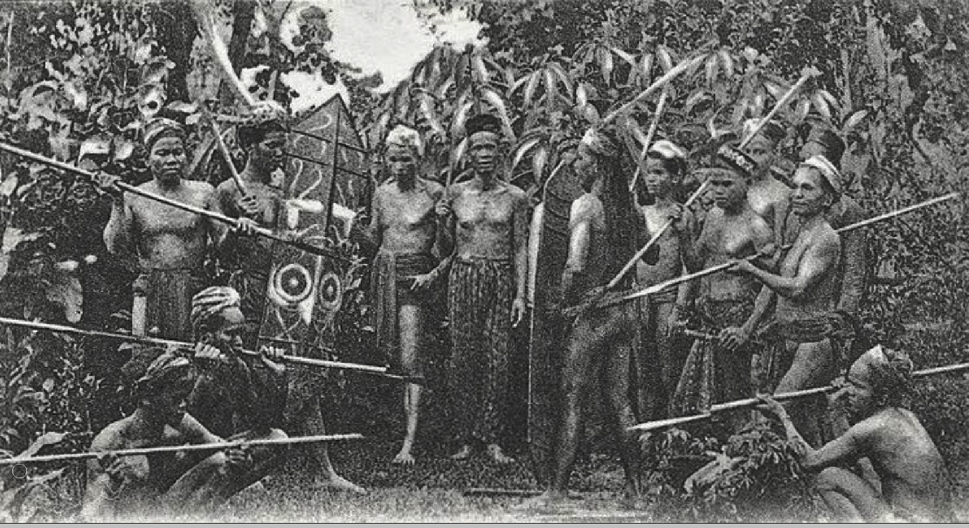

Groet uit Borneo, Ot Danoem. Head hunters in Borneo (Kalimantan), staged scene, from a postcard 1906



Head hunters in Borneo (Kalimantan), from a postcard 1920’s

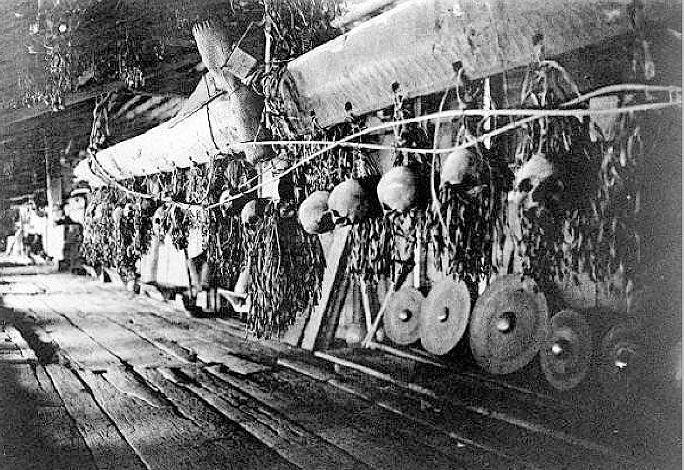

Headhunter s Gallery inside the house with skulls and Padaung Dayak weapons, which become wall hangings, 1900-1930.

**References:**

Schwaner, C.A.L.M. 1846. Borneo. *Ein Bilianfest der Dayak von Sungi Pattaym.* Amsterdam, van Kampen.